Project Demonstration
Field | Link
Live Application | https://jaineshbharti5.github.io/finwise-ai
GitHub Repository | https://github.com/JaineshBharti5/finwise-ai
Demo Video | https://drive.google.com/file/d/1R7yStCQXAuEFCktQstJzgT8etC3Lp7Fr/view?usp=sharing

Demonstration Walkthrough
1. Landing Page - overview of all four modules with live snapshot cards (loan amount, credit score, EMI).
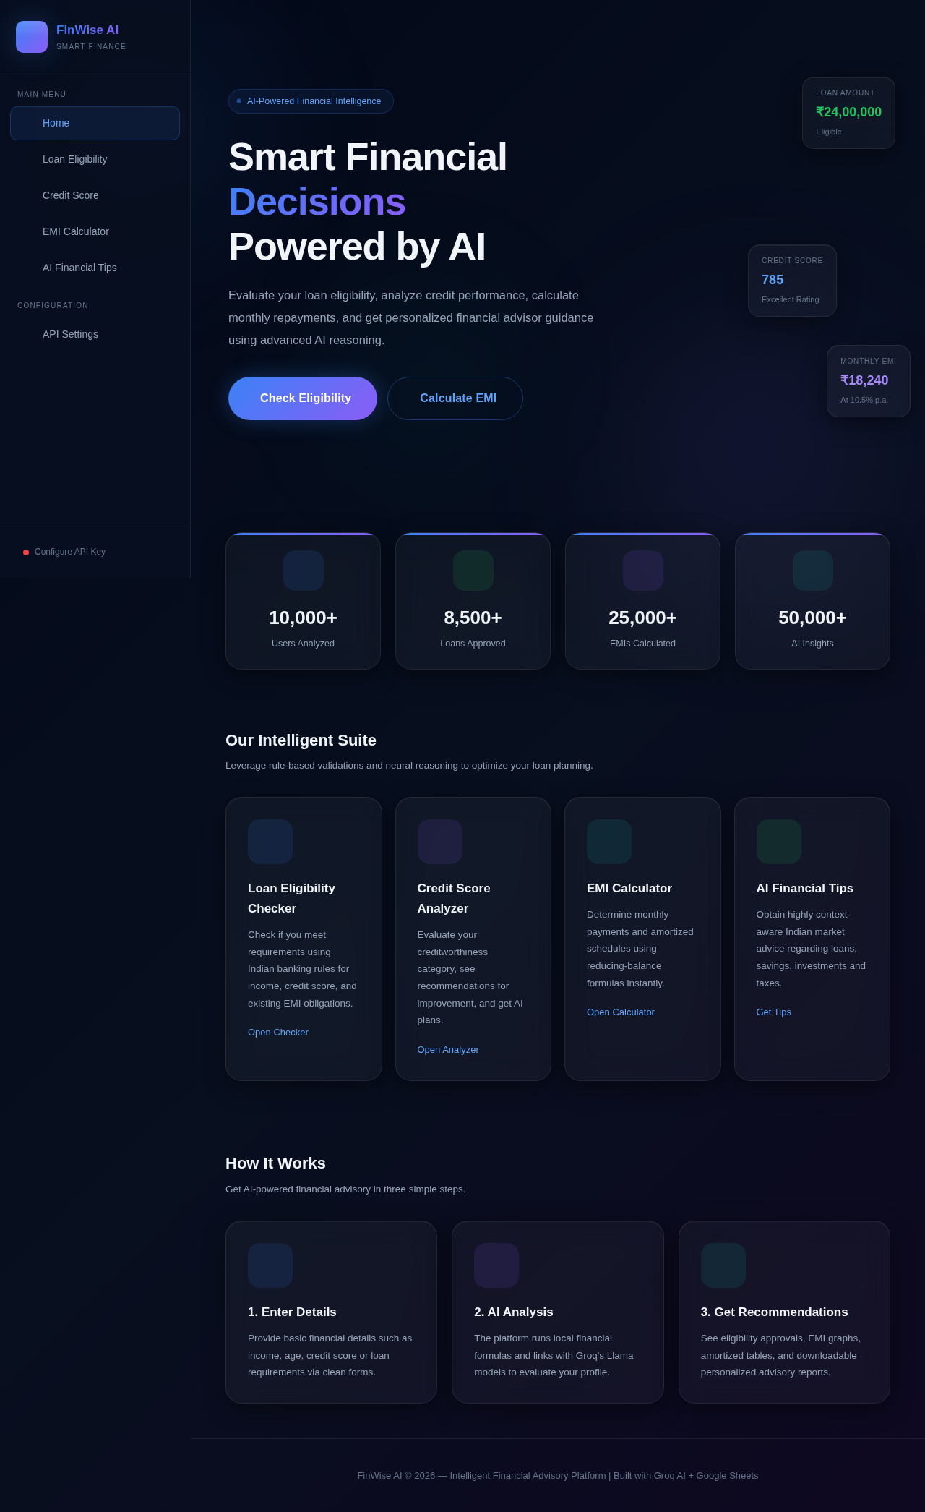
2. Loan Eligibility Checker - user enters salary, credit score, EMI and age; system evaluates against BFSI thresholds and shows eligible amount.
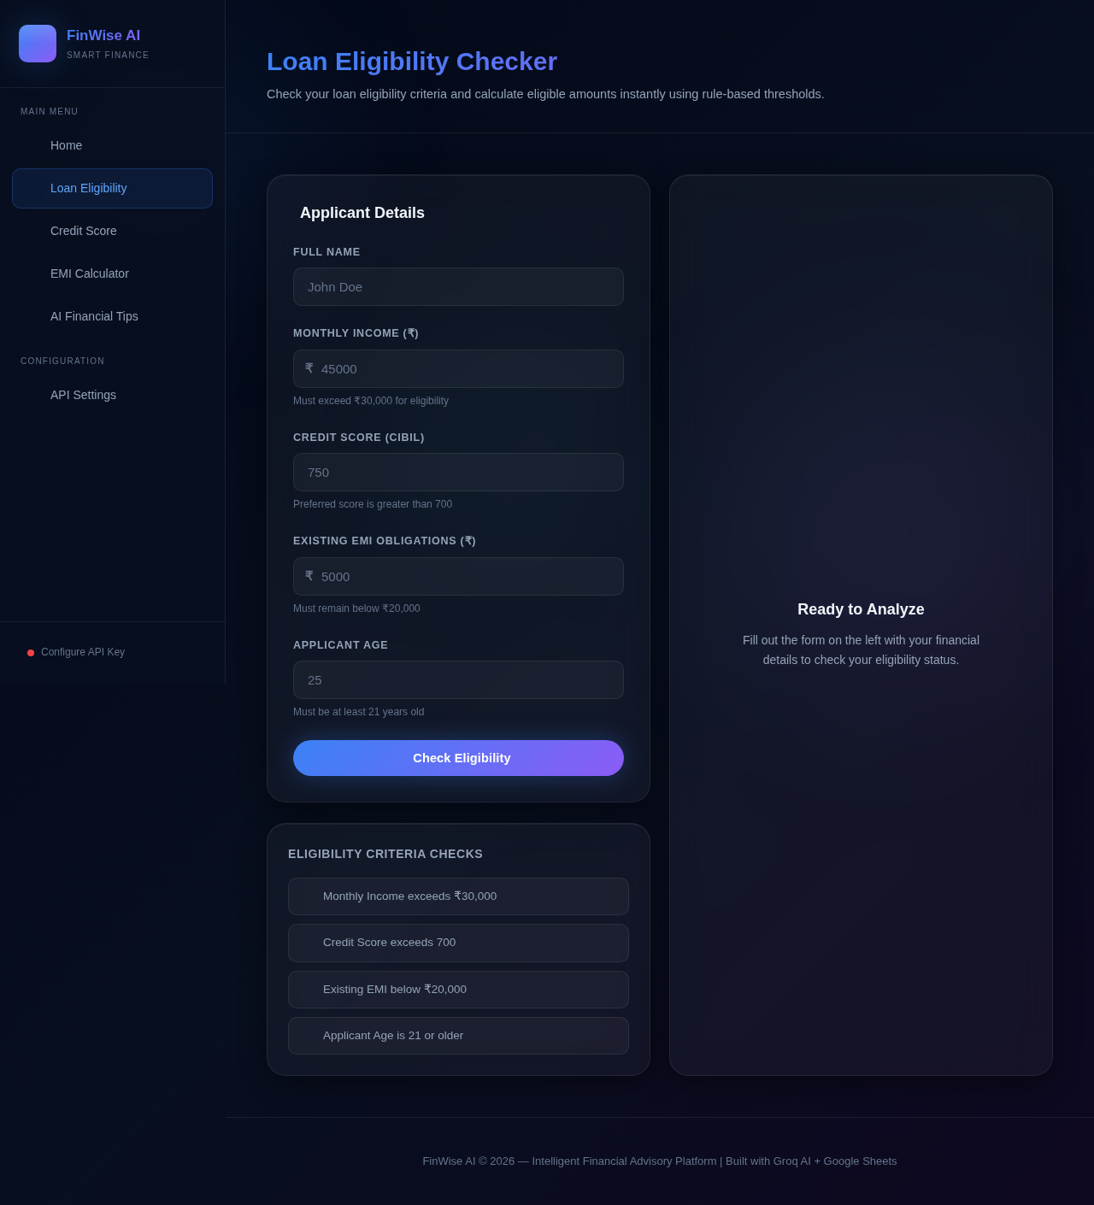
3. Credit Score Analyzer - classifies the entered score into Excellent / Good / Poor with guidance.
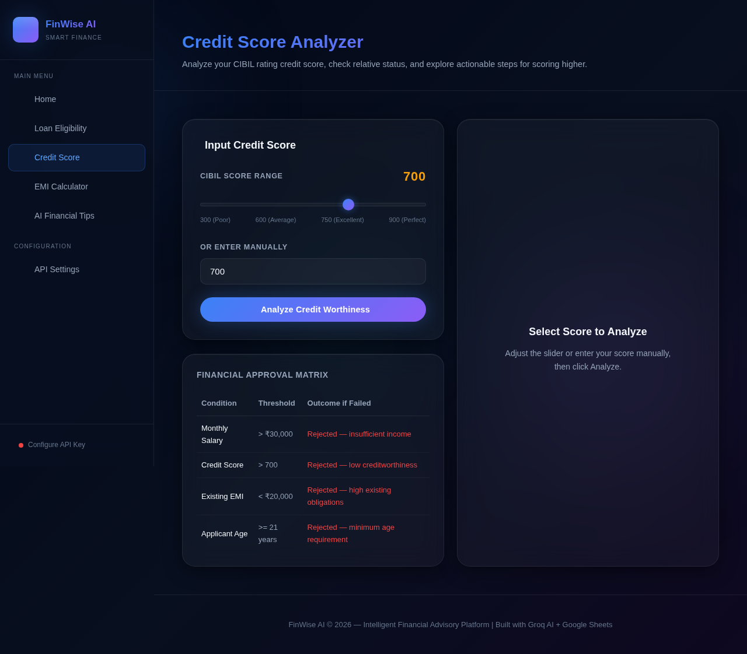
4. EMI Calculator - computes monthly instalment using the reducing-balance method.
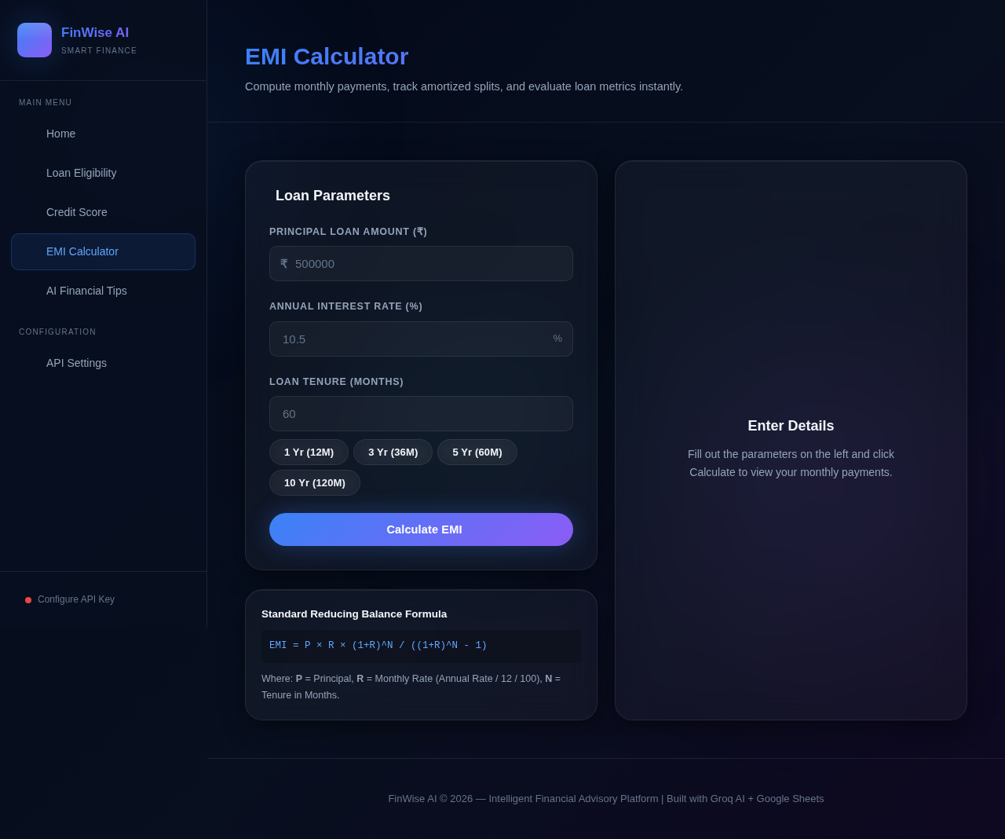
5. AI Financial Tips - Groq AI generates personalised guidance based on the user's financial profile; the result is also logged to Google Sheets in the background.
